Interaction Laws for Dependability Explicit Computing in Open Multi-agent Systems

Rodrigo Paes, Gustavo Carvalho, Carlos Lucena
LES, PUC-Rio
Rua Marquês de São Vicente 225, Rio de Janeiro/RJ, Brazil, 22453-900
[rbp, guga, lucena]@inf.puc-rio.br

Ricardo Choren
SE/8, IME
Praça General Tibúrcio 80, Rio de Janeiro/RJ, Brazil, 22290-270
choren@ime.eb.br

Abstract: In an open multi-agent system (MAS), agent autonomy and heterogeneity may possibly exploit cooperation, leading the system to an undesirable state. Since a MAS has no central control, a coordination mechanism must be developed to allow agents to fulfill their design goals. In this paper we propose to incorporate the Dependability Explicit Computing (DepEx) ideas into a law-governed approach in order to build dependable open MAS. We show that the law specification can explicitly incorporate dependability concerns, collect data and publish them in a metadata registry. This data can be used to realize DepEx and, for example, it can help to guide design and runtime decisions. The advantages of using a law-approach are (i) the explicit specification of the dependability concerns; (ii) the automatic collection of the dependability metadata reusing the mediators’ infrastructure presenting in law-governed approaches; and (iii) the ability to specify reactions to undesirable situations, thus preventing service failures.
I. INTRODUCTION
Many current systems are open and dynamic. A key characteristic is that they demand dynamic binding, i.e. the selection and use of components at runtime. Autonomous agents and multi-agent systems (MAS) represent a new way of analyzing, designing, and implementing open, dynamic software systems [7]. An open MAS does not simply consist of agents selected during a design activity. Instead, they are open to agents that may arrive, depart or be modified. They are dynamic in order to provide services on a continuous basis, and do so even when agents or the environment change [15].
Aside from inherent complexity, such software systems usually evolve continuously by adding, replacing, modifying or removing software agents. Thus, the problem of maintaining the dependability of open MAS arises. Indeed, achieving dependability in open MAS is particularly challenging. Such systems have little or no control over the actions the agents can perform and the internal aspects of the agents (e.g. implementation language and architecture) are inaccessible.
The dependability of a computing system can be defined as the ability of a system to avoid failures that are more frequent or more severe, and outage durations that are longer than acceptable [1]. Dependability is an integrating concept that encompasses the following attributes [1]: availability (readiness for correct service); reliability (continuity of correct service); safety (absence of catastrophic consequences on the user(s) and the environment); integrity (absence of improper system alterations), and; maintainability (ability to undergo modifications and repairs).
A MAS is said to be dependable if it or its constituent agents include internal mechanisms that guarantee that all services are rendered according to specification even in the presence of disturbances [10]. One way to promote dependability in open MAS is by implementing a Dependability Explicit Computing (DepEx) approach [9]. DepEx main idea is to incorporate effective concern for the achievement of any necessary dependability targets into the full system life cycle. Thus design and implementation files are annotated with dependability-related metadata, which are updated when the files are processed (e.g. when development moves from one phase to another). Then at the runtime, the dependability metadata can be exploited to aid decision-making. Examples of metadata are safety integrity level, failure rates, pre and post conditions, mean time between failures (MTBF), response time, resources consumed, etc.
To incorporate dependability issues throughout an open MAS development life cycle, i.e. to use a DepEx approach, is not easy – as mentioned, there is little or no control over the development of each individual agent. However, agents must interact to achieve their goals. If an agent does not interact properly, it will not be able to render its service. Thus it would be interesting to provide a structure that can deal with dependability issues using the interaction specification as a starting point.
Interaction laws explicitly specify behavioral rules, and provide mechanisms to check if the actual interactions conform to the specification at runtime. These checking mechanisms are usually implemented by either a central mediator or by a decentralized community of mediators [11]. The mediators perform the active role of monitoring the interaction among the agents and interpreting the laws to verify if the actual system behavior is in conformance with the specifications.
The main thesis of this work is to use the interaction law approach to deal with dependability issues. The idea is to specify dependability meta-data together with the specification of interaction laws and to use and check these meta-data during message conformance checking. Thus the contributions of this paper are an interaction law specification language (XMLaw) and a mediator infrastructure (M-Law) to incorporate DepEx ideas into the development of dependable open MAS. We understand that law specification can explicitly incorporate dependability concerns, collect data and publish them in a metadata registry. The advantages of using interaction laws to implement a DepEx approach are (i) the explicit specification of the dependability concerns; (ii) the automatic collection of the dependability metadata reusing the mediators’ infrastructure presenting in law-governed approaches; and (iii) the ability to specify reactions to undesirable situations, therefore, preventing service failures.
This paper is organized as follows. Section 2 presents a flexible law-governed approach called XMLaw. This approach is used throughout the examples given in this paper. Section 3 presents a case study to discuss how the laws can be used to promote DepEx. Section 4 presents how XMLaw and M-Law can be used to implement the DepEx approach. Section 5 shows an application scenario of the proposed solution. Section 6 shows some related work on promoting dependability in open MAS. Finally, Section 7 presents some conclusion about this work.

II. THE XMLAW LANGUAGE
XMLaw [12] is used to represent the interaction laws of an open system specification. A law specification is a description of law elements that are interrelated in a way that makes it possible to represent interaction protocols. XMLaw follows an event-driven approach, i.e., law elements communicate by the exchange of events. The XMLaw law elements are defined in a conceptual model (figure A). This conceptual model is composed of the following main elements: event, protocol, transition, state, scene, clock, norm, constraint, action.
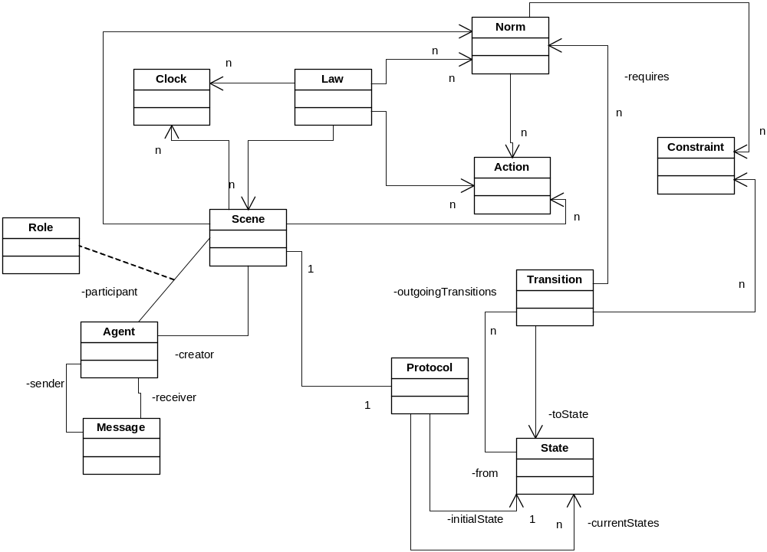
Figure 1: The XMLaw conceptual model
The event element is at the heart of the XMLaw language. It models an occurrence related to the elements of the law. For instance, an event can represent a change of state of a protocol, the arrival of a message sent by an agent, the moment in which an agent acquires an obligation and an announcement that a certain amount of time has elapsed. The semantic of each event is determined by its type. Examples of types of events in XMLaw are: message_arrival, message_send, compliant_message, transition_activation, failure_scene_completion, sucessful_scene_completion, scene_creation, clock_activation, clock_tick, clock_timeout, clock_deactivation, norm_activation, norm_deactivation.
A protocol defines a state machine that describes the possible paths an agent interaction can follow. Each individual interaction path in a protocol is called a conversation. A state models a possible step in the evolution of an interaction. States can represent static or dynamic situations and there are three types of states: successful, failure or execution. A successful state means that the protocol stops upon reaching success. A failure state means that the protocol stops with failure when the state is reached. An execution state does not stop the protocol.
A transition is a directed arc between a source state and an end state. It represents the change between two different situations in the course of an interaction caused by a response to the occurrence of an XMLaw event. This is an important advantage of XMLaw: transitions between states can be fired by any event, instead of only message arrivals. Therefore, protocols specify the expected sequence of events in the path of interaction among agents.
Accordingly, transitions may depend on norms and constraints to fire. For instance, if there is a permission associated with the transition, the permission must be active in order to fire the transition. Constraints, on the other hand, may act as fine-grained filters for transitions. For instance, a constraint could access a database, do some math, calculate date periods or perform any other complex domain-dependent operation in order to allow the transition to fire.
Scenes help organize interactions. The concept of scenes used here is similar to those in theatre plays, where actors play a role according to well defined scripts, and the entire play is composed of many connected scenes. A scene models an interaction context where protocols, actions, clocks and norms can be composed to represent complex normative situations. Furthermore, from the problem modeling point of view, a scene allows for the decomposition of the problem into smaller and more manageable pieces of information. They can be viewed as building blocks of normative interactions. Normative interactions are situations in which agents interact through a set of behavioral rules, or social conventions.
A clock represents a time restriction or controls and it can be used to activate other law elements. Clocks are activated and deactivated by other law elements. Once activated, a clock generates clock_tick events, which are used to indicate that a certain period has elapsed.
A norm is an element used to enable or disable conversation paths. For instance, a norm can be used to prevent an agent from interacting in a negotiation scene. There are three types of norms with different semantics in XMLaw: obligations, permissions and prohibitions. The obligation norm defines a commitment that agents acquire while interacting with other entities. The permission norm defines the rights of an agent at a given moment. Finally, the prohibition norm defines forbidden actions of an agent at a given moment.
Consider an auction negotiation scene to illustrate the types of norms. In this scene, agents interact to buy a given item. One of the agents is declared the winner of the auction (this depends on the type of auction). Once an agent is declared the winner of the auction, it is obligated to pay the committed value. This obligation norm can also describe some penalties in order to prevent the winner agent from breaking this commitment. Another example would be that the winner agent gains the permission to interact with a banker agent through a payment protocol. This permission norm does not make any impositions on the agent, i.e. it is free to decide whether or not to initiate the payment protocol. At last, if an agent does not pay its debts, it will not be allowed future participation in a scene. This prohibition norm blocks other conversations for this agent in this scene.
It is interesting to mention that a norm can generate activation and deactivation events (norm_activation and norm_deactivation). As a consequence, it is possible to describe relationships between norms and transitions. For instance, it is possible to specify which norms must be made active or deactivated for firing a transition. In this sense, a transition could only be fired if the sender agent has a specific norm.
The structure of the permission, obligation and prohibition elements is the same. Each type of norm contains activation and deactivation conditions. Code 1 shows an example of permission norm (assemblerPermissionRFQ). This norm will allow an assembler agent to send a limited number of request for quote (RFQ) messages every day. Line 1 describes the heading of the norm. It states the following: this is a permission to be given to the assembler upon logging into the scene until the agent issues an order. In fact, a norm heading has four parts: its type (in this example, permission); the agent that will be affected by the norm (in this example, assembler); the event that will activate the norm (in this example, the agent logging into the negotiation scene, described using a scene_activation event, called (negotiation)), and; the event that will deactivate the norm (in this example, the agent sending an order message – that should be further detailed elsewhere in the protocol – described using a message_send event, called (orderTransition)).
Code 1: XMLaw specification of a norm (permission)
// norm definition
01: assemblerPermissionRFQ {
permission, $assembler, (negotiation), (orderTransition)

// constraint declared in the context of the norm
02: checkCounter{br.pucrio.CounterLimit}

// actions declared in the context of the norm
03: permissionRenew{(nextDay), br.pucrio.ZeroCounter}
04: rfqTransition{(rfqTransition), br.pucrio.RFQCounter}

05: } //end norm definition

A constraint is a restriction to norms or transitions and, generally, it specifies filters for events, constraining the allowed values for a specific attribute of an event. For instance, messages carry information that is enforced in various ways. A constraint can be used to describe what the allowed values for each specific message attribute are. Constraints are defined inside scene (Code 2) or norm (Code 1) elements and they are implemented using Java code. The constraint element defines the class attribute that indicates the Java class that is called when a transition or a norm is supposed to fire.
For example, Code 1 shows the definition of a norm constraint (checkCounter). It defines a Java class (br.pucrio.CounterLimit) that will restrain the norm. The norm described in Code 1 limits the number of RFQ messages an assembler agent is permitted to send in a day. Thus the br.pucrio.CounterLimit Java class should provide code to define the actual limit of RFQ messages, to increase a counter every time the agent sends a RFQ message and to indicate the counter reached the limit. This indication should be sent to the M-Law infrastructure, which, in turn, will indicate that the permission is no longer valid. As a consequence the M-Law infrastructure will block RFQ messages sent by the assembler agent from this moment on.
Code 2 shows the definition of a scene constraint (checkDueDate). It defines a Java class (br.pucrio.ValidDate) that will restrain the scene. This constraint is used, in this example, to verify if the date expressed in a message sent in this scene is valid. It works just like the checkCounter constraint described above.
Code 2: Constraint checkDueDate used by a transition
01: negotiation{
...
09: t1{s1->s2, rfqMsg, [checkDueDate]}
...
14: checkDueDate{br.pucrio.ValidDate}
...
20:} // end scene

An action supports the definition of the moment when the mediator should call a domain-specific service. Actions are domain-specific Java code that runs in an integrated manner with XMLaw specifications. An action can be defined in the scope of a law, a scene or a norm. Since actions are also XMLaw elements, they can be activated by any event such as transition activation, norm activation and even action activation.
In fact, an action can be used to plug services into a governance mechanism. For instance, a mechanism can call a debit service from a bank agent to charge the purchase of an item automatically during a negotiation. In this case, we specify in the XMLaw that there is a class that is able to perform the debit. This notion could also be extended to support other technologies instead of Java, such as direct invocation of web services.
The structure of an action is shown in Code 1. Lines 3 and 4 describe two norm actions. The permissionRenew action will renew the assemblerPermissionRFQ norm every day. It is activated by a clock_timeout event (nextDay) – that should be further detailed elsewhere in the protocol. When the event is fired, a Java class (br.pucrio.ZeroCounter) is executed. In this example, this class will set the RFQ message counter of an assembler agent to zero. This will change the state of the checkCounter constraint (the message limit is not reached). As a consequence, the constraint class will send a message to the M-Law infrastructure indicating that the assemblerPermissionRFQ permission is valid again. It is important to mention that, in this example, the action is activated by only one event. However, XMLaw allows any number of events to activate an action.
The flexibility achieved by using the event-driven approach at a high-level of abstraction is not present in the other high level law approaches [3, 5]. The advantages claimed in favor of the use of events as a modeling element are also present in LGI [11], however at a low level of abstraction. A flexible underlying event-based model as presented in XMLaw can allow conceptual models for governance to be more prepared to accommodate changes. This is specially needed when we consider using the law-approach to deal with new concerns not considered in its original specification, such as dependability.

III. THE M-LAW INFRASTRUCTURE
XMLaw laws are interpreted by the M-Law mediator [14] that provides a communication component for enforcing interaction laws at runtime, i.e. which analyzes the compliance of agents with interaction law specifications. M-Law was designed to allow extensibility in order to fulfill open system requirements or interoperability concerns.
The M-Law mediates the communication between the agents according to the specified in the XMLaw file it reads. In fact, M-Law works by intercepting messages exchanged between agents, verifying the compliance of the messages with the laws and subsequently redirecting the message to the real addressee, if the laws allow it. If the message is not law compliant, then the mediator blocks the message and applies the consequences specified in the law (Figure 2).
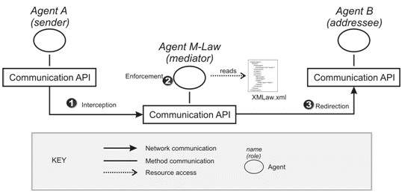
Figure 2: M-Law architecture
The M-Law mediator is composed of three modules: event, component and communication. The event module implements event notification and propagation. It is basically an implementation of the observer design pattern [6] allowing elements for listening and receiving events. The communication module has a similar implementation as the communication module on the client side.
The elements such as scenes, clocks and norms, are implemented to be plugged into the component module. Thus the component module carries out the actual law enforcement, which is application specific. In other words, components are the set of classes placed in the mediator that implements the behavior of the XMLaw language elements. A more detailed discussion on the design and implementation of the M-Law modules can be found in [13].
As an example of how M-Law works in a practical scenario, suppose an agent playing the role of an employer asks for increasing its own salary to other agent playing the role of accountant. However, there is a norm specified in XMLaw stating that employers are prohibited from asking for salary increase. Despite the simplicity of this scenario, it is useful to illustrate the basic flow of events inside the MLaw.
In this scenario, the M-Law infrastructure works in the following way:
- The mediator agent reads the XMLaw specification and starts the component module;
- The employer agent calls its communication module and sends the request message asking for salary increase;
- The communication module redirects the message to the mediator;
- The mediator receives the message through its communication module;
- The mediator fires an event of message arrival through event module;
- The event module notifies the component module;
- The component module receives the event. Then, using a set of application specific law enforcement classes, verifies that the message is not allowed and fires a message not compliant event;
- The mediator receives the message not compliant event and as a consequence, does not redirect the message to the accountant agent.
The current implementation of the M-Law infrastructure is done in Java and it uses the JADE platform communication component. This is presently limiting the solution for JADE agents. However, we believe that this does not hinder the openness characteristics of a MAS in the sense that the agents can be developed elsewhere (not by one developer) and anyhow (with no specific code regarding law enforcement). Besides the M-Law infrastructure allows agents to enter and leave the open MAS at any time.

IV. IMPLEMENTING DEPEX USING XMLAW
DepEx intends to incorporate effective concern for the achievement of any necessary dependability targets into the full system life cycle. This involves identifying explicit dependability requirements and exploiting this information throughout the development process, and during system deployment, in order to provide dependability-related guidance to all decisions. The notion is to annotate all design information files (e.g. specifications, code, etc.) with dependability-related meta-information, and to use and update this meta-information as the files themselves are processed [8].
XMLaw is used to specify laws in such a way that the dependability metadata is treated as first-class data. Currently, the metadata information present in law definitions using XMLaw includes metadata concerning availability, service failure and enforcement of pre and post conditions.
(i) Availability: every time an agent sends a request to other agent, the receiver should answer within a pre-specified amount of time. The absence of an answer implicates that at that time the receiver was not available with the required quality level.
(ii) Service failure: during the interaction, agents acquire obligations that they must fulfill. The fulfillment of these obligations represents the expected correct behavior for the agents. Therefore, each obligation that is not fulfilled can be interpreted as a service failure, i.e., the actual system execution deviates from the correct behavior.
(iii) Pre and post conditions: agent specifications may change as agents evolve, but resilience may be maintained if it is possible to reason dynamically about the functional properties of agents, including abnormal behaviors. Dynamic resilience mechanisms require agent specifications as metadata, including both specifications of services offered and services required. These can be given by pre and post-conditions, potential failure behaviors and responses when the components are used outside their pre-conditions.
Such meta-information is likely to be composite in open MAS, and it should be processed using meta-level operations associated with tools that will carry forward the dependability process. The M-Law middleware is used to process dependability metadata specified with XMLaw. The main idea is that XMLaw will be used to describe dependability information during system development thus providing a trace of the dependability-related decisions and actions taken during design. Then M-Law will execute meta-level operations, providing traceable evidence regarding the dependability of the system.
IV.1. DepEx Architecture using XMLaw and M-Law
To allow the development and implementation of DepEx concepts using XMLaw and the M-Law middleware a metadata architectural model was conceived for the achievement of predictable levels of dynamic resilience in distributed systems (Figure 3). The architecture is based on the model presented in [15]. This model was chosen because it already contains the components to enable DepExp. It has a metadata registry, a runtime reasoning/adaptation service and a metadata acquisition component.
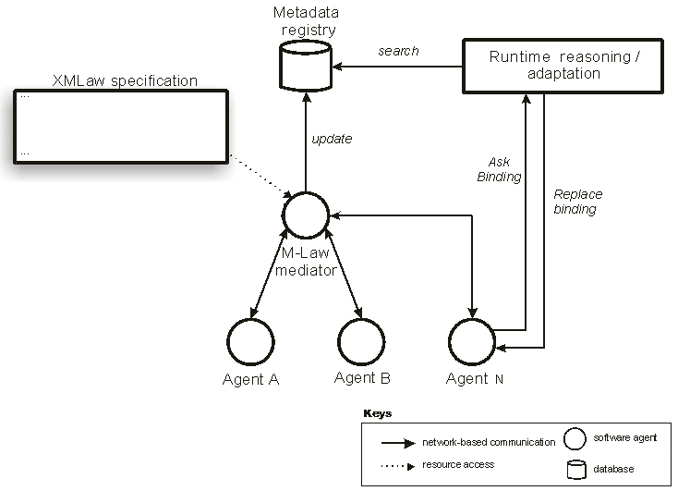
Figure 3: The XMLaw and M-Law Architecture for DepEx
The architecture is composed of five components: the M-Law mediator, the XMLaw specification, the metadata registry, the runtime reasoning and the application agents. As stated before, the M-Law mediator intercepts messages exchanged between agents and verifies the compliance of these messages with the laws. The architecture is based on a pool of mediators that intercept messages and interpret the previously described laws. As more clients are added to the system, additional mediators’ instances can be added to improve throughput.
In the XMLaw specification there are instructions that tell the mediator how to update the metadata registry. At runtime, the metadata registry can be used in two ways: directly by the agents or through the runtime reasoning. The agents can proactively search for metadata and self-adapt to reflect their dependability requirements. As an example, a user agent can search for a travel agent that has not broken any obligation during the last month.
The runtime reasoning provides different tasks related to the processing of metadata stored in the metadata registry, such as comparison/matching of metadata, determination of equivalent metadata information and composition of metadata [15]. This service manages the list of agents, seamlessly activating or connecting the ones that will be used according to a specified resilience policy program.

V. A SAMPLE SCENARIO
This section presents a motivating case study to illustrate how to specify the laws in such a way that the dependability metadata is treated as first-class data. The problem description was already reported in [16], and it was slightly modified to this case study.
Consider the task of creating a system composed of three types of agents: a travel agent, a user agent and an airline agent. The airline provides several related operations, which must be invoked according to a complex conversation protocol. Assume that the airline agent provides five different operations: checkSeatsAvailability, reserveSeats, cancelReservation, bookSeats, and notifyExpiration. Each operation performs a single airline travel related task. The operations must be invoked by a client according to the following conversation rules:
- checkSeatsAvailability must be the first operation to be invoked;
- reserveSeats may only be invoked if a client has already invoked checkSeatsAvailability and the requested seats are indeed available; the reservation is held only for a certain amount of time;
- bookSeats or cancelReservation may be invoked, but only if the seats have been reserved (by a successful invocation of reserveSeats) and the reservation has not expired;
- if neither bookSeats nor cancelReservation has been invoked by the client within a specified amount of time, the airline agent will itself invoke notifyExpiration to inform the client that the reservation has expired.
A user agent, planning on taking a trip submits a TripOrder to its travel agent, hoping to get an itinerary proposal. The TripOrder is sent through the getItinerary message and contains information such as departure and destination, departure date and time, and return date and time (for a round trip), the number of maximum connections and the number of travelers. The travel agents finds the best itinerary to reach the destination based on the traveler’s criteria such as the cheapest fare, availability of flights, or frequent flyer miles accumulated by the traveler. Before the Itinerary can be proposed to the traveler, the travel agent invokes the airline agent to verify the availability of seats (checkSeatsAvailability). In the event the seats are available, the travel agent notifies the traveler and waits for the traveler to submit a modified TripOrder.
If seats are available, the proposed itinerary is sent to the traveler for confirmation. The treveler then decides to reserve the seats for the itinerary and gives the travel agent its contact information so that the airline agent can send it an e-ticket. Next, the travel agent interacts with the airline agent to finalize the reservation (reserveSeats). Assume that the airline holds such reservation for one day, and that if a BookRequest is not received within one day, the seats are released and the travel agent is notified. The travel agent sends a ReserveResult message to the traveler as an acknowledgment.
At this point, the traveler can either book or cancel the reservation. If it decides to book the trip, it sends a BookRequest to the travel agent containing its credit card information. The travel agent then invokes the bookSeats operation of the airline agent to finally book the seats. As a result, the airline agent books the seats for the proposed Itinerary, and issues an e-ticket to the traveler.
V.1. Some Sample Scenario Requirements
This section will illustrate six requirements for the sample scenario, described above, which can be explicitly related to dependability issues.
- The whole process must occur within two days. After two days, the process is cancelled and all the rules are no longer valid. All the interactions must restart.
- All interactions must take place in the pre-defined order specified in the problem description (Section IV).
- If the airline agent says there is a seat available, this seat must be locked for the travel agent for at least five minutes. This way, the user has some time to decide whether to confirm the reservation. If the time has elapsed, and the airline has not received any confirmation, then the airline is allowed to answer with a not-available message and book the seat for another client.
- When the airline agent sends a result-ok message in response to a seat reservation, then the reservation must be held for at least one day
- The TripOrder (getItinerary message) must belong to the set of possible attributes S={“Toronto”, “New York”, “London”, “Tokyo”, “Rio de Janeiro”}.
- Every request that does not require user interaction must be answered within 15 seconds by any agent.
V.2. Dependability Metadata Acquisition through XMLaw Specification
The sample scenario protocol can be described as a state machine (Figure 4). The complete XMLaw specification for this protocol is shown in Code 3. The scene is declared in lines 01 and 02. Lines 03 to 16 show the pattern of messages that agents are expected to exchange. Lines 17 to 20 specify the initial and final states of the interaction protocol. The transitions are specified in lines 21 to 37. The transitions refer to the states, messages, constraints and norms present in the law. Clocks are specified in lines 38 to 40, constraint in line 41, actions in lines 42 to 44, and norms in lines 45 and 46.

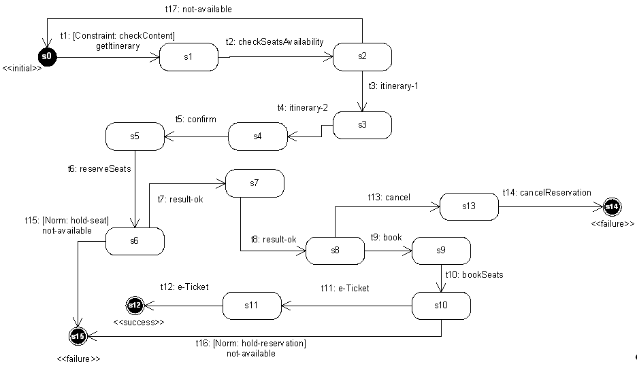
Figure 4: Sample scenario protocol specification
Code 3: Sample scenario XMLaw specification
// scene specification
01:planningATrip{
02: time-to-live=2d
// pattern of messages
03: getItinerary{userAgent,travelAgent,
trip_order($dep, $dest, $depDate, $depTime, $retDate,
$retTime, $maxCon, $travellers)}
04: checkSeatsAvailability{travelAgent,airlineAgent, $trip_order}
05: itinerary-1{airlineAgent, travelAgent, itinerary($id,$details)}
06: itinerary-2{travelAgent, userAgent, itinerary($id,$details)}
07: confirm{userAgent, travelAgent, confirm($id)}
08: reserveSeats{travelAgent, airlineAgent, reserveSeats($id)}
09: result-ok-1{airlineAgent, travelAgent, ok($id)}
10: result-ok-2{travelAgent, userAgent, ok($id)}
11: book{userAgent, travelAgent, book($id)}
12: bookSeats{travelAgent, airlineAgent, bookSeats($id)}
13: e-Ticket{$sender, $receiver, e-ticket($ticketId)}
14: cancel{userAgent, travelAgent, cancel($id)}
15: cancelReservation{travelAgent, airlineAgent, cancelReservation($id)}
16: not-available{airlineAgent, travelAgent, not-available($id)}

// initial and final states
17: s0{initial}
18: s12{success}
19: s14{failure}
20: s15{failure}

// transitions
21: t1{s0->s1, getItinerary, [checkContent]}
22: t2{s1->s2, checkSeatsAvailability}
23: t3{s2->s3, itinerary-1}
24: t4{s3->s4, itinerary-2}
25: t5{s4->s5, confirm}
26: t6{s5->s6, reserveSeats}
27: t7{s6->s7, result-ok-1}
28: t8{s7->s8, result-ok-2}
29: t9{s8->s9, book}
30: t10{s9->s10, bookSeats}
31: t11{s10->s11, e-Ticket}
32: t12{s11->s12, e-Ticket}
33: t13{s8->s13, cancel}
34: t14{s13->s14, cancelReservation}
35: t15{s6->s15, not-available, [hold-seat]}
36: t16{s10->s15, not-available, [hold-reservation]}
37: t17{s2->s0, not-available}

// Clocks
38: availability-clock{15s, regular, (t1,t2,t3,t5,t6,t7.t9,t10,t11,t13), (t2,t3,t4,t6,t7,t8,t10,t11,t12,t16,t17)}
39: hold-seat-clock{5m, regular, (t3), (t6)}
40: hold-reservation-clock{1d, regular, (t7), (t10)}

// Constraints
41: checkContent{br.pucrio.CheckContent}

// Actions
42: updateClockMetadata{(availability-clock), br.pucrio.DecAvailability}
43: updateHoldSeatMetadata{((hold-seat, norm_not_fulfilled)), br.pucrio.HoldSeat}
44: updateHoldReservationMetadata{((hold-reservation, norm_not_fulfilled)), br.pucrio.HoldReservation}
// Norms
45: hold-seat{obligation, airlineAgent, (t3), (hold-seat-clock, t7)}
46: hold-reservation{obligation, airlineAgent, (t7), (hold-reservation-clock , t11)}
47:}

The six requirements listed in section IV.1 can be specified as laws using XMLaw, as follows. Requirement R1 is implemented as the time-to-live scene attribute in line 02. The interaction protocol in Figure 3 reflects exactly the possible paths of interactions described for the sample scenario. This protocol is specified in lines 03 to 37. These lines declare all messages, states and transitions present in the protocol, describing requirement R2.
Requirement R3 demands a combined use of various XMLaw elements. First, it is necessary to identify when the airline agent says “there is a seat available”. Then, we have to start to count five minutes. The airline is not allowed to answer not-available within these five minutes. Table 1 shows the sequence of observed events that makes it possible to specify this requirement. This table is mapped to the XMLaw specifications in lines 35, 39, 43 and 45 in Code 3.
Requirement R4 is specified in XMLaw using an idea similar to requirement R3. The transition t16 (line 36) only fires if the obligation hold-reservation (line 46) is deactivated. The clock hold-reservation-clock (line 40) counts the time until one day. And the action updateHoldReservationMetadata updates the metadata registry with information about agents that do not fulfill the obligation.
Table 1: Rationale for the XMLaw specification of the req. 3 in lines 35, 39, 43 and 45
Airline agent sends itinerary-1 message to the travel agent. It means that airline agent is saying: “there is a seat available”. Then, we activate the clock to start counting the time. Moreover, we also activate the obligation hold-seat, and give it to the airline agent.
WHEN (t3, transition_activation)
ACTIVATE hold-seat-clock, hold-seat
If the time that the airline must hold the seat has elapsed (clock_tick event), then the obligation does not need to be fulfilled, i.e., the airline agent can answer with a not-available message.
WHEN (hold-seat-clock, clock_tick)
DEACTIVATE hold-seat
If the airline agent answers with a result-ok to a reserveSeats requisition, it means that the airline agent has fulfilled its obligation of holding the seat. Then, the obligation should be deactivated.
WHEN (t7, transition_activation)
DEACTIVATE hold-seat
The transition t15 only fires if the obligation hold-seat is deactivated. If the airline sends the not-available message while the obligation is still active, then a norm_not_fulfilled event will be generated and the transition will not fire. As we are concerned with acquiring metadata about agents that do not follow the rules, the non-fulfillment of an obligation should be reported to the metadata registry. The action updateHoldSeatMetadata is in charge of obtaining the contextual information such as the agent, the obligation id (in this case hold-seat) and updating the registry.
WHEN (hold-seat, norm_not_fulfilled)
ACTIVATE updateHoldSeatMetadata

The constraint checkContent specified in line 41 is invoked by the transition t1 (line 21). The constraint verifies if the values of the variables dep and dest (line 03) belong to the set of the pre-defined cities, implementing requirement R5. The constraint implementation is shown in Code 4.
Requirement R6 states that agents that do not wait for input from the user must not take too long to provide an answer. The availability-clock specified in line 38 counts 15 seconds every time an agent receives a request. The clock is reset when the agent answers the request. The transitions t1, t2, t3, t5, t6, t7, t9, t10, t11, and t13 specified in the clock, represent requests to agents. Note that transitions such as t4 are not present in this list. This is because t4 represents a message that is sent to the user (through the user agent). Every time an agent does not answer within the 15s, the clock generates a clock_tick event. This event is listened to by the action updateClockMetadata (line 42). The action updates the metadata registry indicating that the agent was not available at that time. The code for this action is shown in Code 5.
Code 4: Java Implementation of the CheckContent Constraint
class CheckContent implements IConstraint{
private static List<String> allowed = new ArrayList<String>();
private void init(){
allowed.add("Toronto");
allowed.add("New York");
allowed.add("London");
allowed.add("Tokyo");
allowed.add("Rio de Janeiro");
}
public boolean constrain(ReadonlyContext ctx){
String dep = ctx.get(“dep”);
String dest = ctx.get(“dest”);
if ( !allowed.contains(dep) || !allowed.contains(dest) ){
return true; // constrains, transition should not fire
}
}
}

Code 5: Action updateClockMetadata implemented as the java class DecAvailability
class DecAvailability implements IAction{
private Datasource metadataRegistry;
...
public void execute(Context ctx){
String addressee = ctx.get(“lastAddressee”);
Event event = ctx.get(“activationEvent”);
metadataRegistry.insert(event, addressee);
}
}

V.3. The Sample Scenario Architecture
The architecture of the sample scenario application (Figure 5) is an extension of the proposed DepEx architecture with M-Law. The application architecture presents the M-Law mediator from the architecture style. The XMLaw specification includes the description of the scenario law (Code 3). The metadata registry includes the DepEx data in the format described in the next section. The runtime reasoning was instantiated with a resilience policy program. This program is application dependent and, in the sample scenario, it includes algorithms to check if some of the events are being fulfilled. Finally, the architecture is completed by the application agents.
The application agents exchange messages, which are intercepted by the M-Law mediator. The mediator reads the metadata registry to check if these messages conform to the DepEx requirements. Besides, the mediator can directly ask the runtime reasoning component to retrieve dependability metadata.
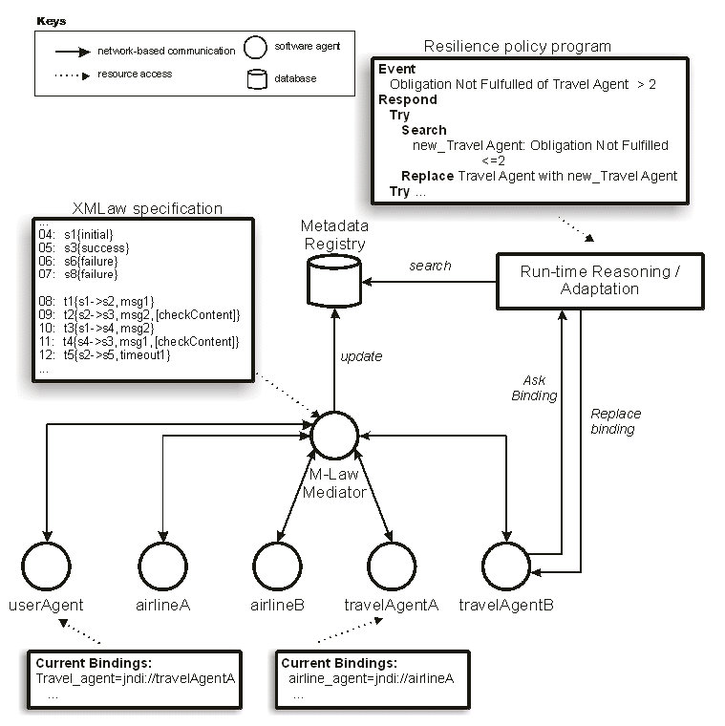
Figure 5: The Sample Scenario Architecture
V.4. The Sample Scenario Metadata Registry
The metadata registry, in this sample scenario, is composed of two entities: agent and dependability_data. The entity-relationship model of the metadata registry is presented in Figure 6, and it is described in Table 2.
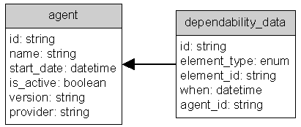
Figure 6: Entity-relationship Model of the Metadata Registry
Table 2: Attribute descriptions
agent | dependability_data
id – unique database identifier of the agent. | id – unique database identifier of the data.
name – the unique name of the agent | element_type – type of the XMLaw element. (eg: obligation, clock, …)
start_date – date when the agent was added to the registry | element_id – id if the XMLaw element
is_active – true if the agent is still running | when – date and time of the insertion of the metadata
version – version of the agent | agent_id – agent identification associated with this metadata
provider – organization that is in charge of the agent

The actions updateClockMetadata, updateHoldSeatMetadata, updateHoldReservationMetadata (lines 42, 43 and 44) are responsible for updating the metadata registry. In fact, these actions update the dependability metadata of the agents at runtime. Figure 7 and Figure 8 show screenshots of the registry database. For example, Figure 8 shows that the airlineA (agent_id=1) has not fulfilled the obligations hold-seat at February 1st and hold-reservation at February 3rd.
It is important to notice that these actions are very simple elements that obtain the contextual information at runtime and update the metadata registry. However, it is the law specification that tells when the actions should execute. In other words, the acquisition of the dependability metadata is done through the combined use of various XMLaw elements. It can clearly be seen in Table 1, where a transition, a clock, a norm and an action were connected to update the metadata.
Figure 7: Sample Scenario Agent Examples
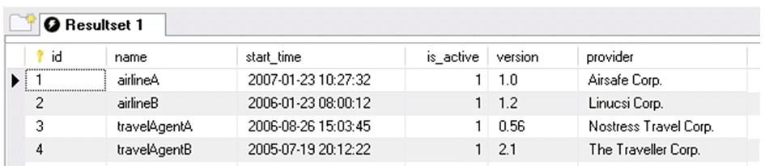
Figure 8: Sample Scenario Dependability Data Examples
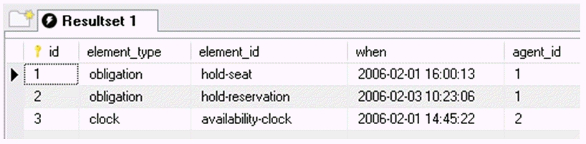

V.5. Some Discussion
The requirements listed on section V.1 were translated to norms that can be described in XMLaw and enforced with M-Law infrastructure. Initially, these interaction laws aim to restrict the behavior of the agents in the system. However, these norms were also used in the context of the DepEx approach.
The availability requirement (readiness for correct service [1]) can be seen on requirements R1 and R6. One way to implement these requirements is to design and code them into the agents. In this way, the agent itself would have, for instance, to take care about the time elapse (e.g. 15 seconds) to ensure its service is available to other agents in the system. This is expensive and, in the context of open MAS, it is hard to verify. If one developer chooses not to implement this requirement or if there are errors in the implementation of this requirement, the service provided by this agent will seem to be unavailable to the other agents.
Other dependability requirements are also handled with the simple set of requirements presented in this sample scenario. Integrity (absence of improper system alterations [1]) can be enforced by the M-Law infrastructure. This can be seen on requirements R2 or R3, for instance. If an agent is modified and it does not conform to these requirements, the infrastructure will not allow it to interact with other agents thus limiting its execution in the system. This also contributes to safety (absence of catastrophic consequences on the user(s) and the environment [1]). If the agent is not allowed to interact its possibly wrong behavior will not be executed in the system.
Maintainability (ability to undergo modifications and repairs [1]) is also achieved by the proposal. The agents, i.e. the services, and the dependability requirements can be maintained separately. The functionality of the system can evolve freely as long as it keeps the conformance to the interaction laws. Nevertheless, none of the requirements listed in the sample scenario deal with reliability (continuity of correct service [1]). As a matter of fact, further study is required to understand how interaction laws can contribute to the continuity of service – in an agent, interaction and service may be separate.
Using the proposal presented in this paper, this requirement will be transformed into XMLaw norms and constraints and the M-Law mediator will be in charge of checking availability. This presents several advantages in the engineering of the solution. For instance, the dependability issues are managed from early stages of development; it eases the design of the agents (fostering modularization and reuse); the requirement is designed and implemented apart from the agent services (allowing them to be tested separately), and; it aids possible system maintenance and evolution (errors in the system services are corrected only in the agents and the services and the dependability requirements can evolve independently).

VI. RELATED WORK
In [4], a position paper is presented that illustrates the use of OWL for dependability specifications. An advantage claimed by the author is that the ontology includes the definition of a controlled vocabulary to avoid ambiguous understanding of the same concept by two different components.
In [2], a tool was presented for monitoring the dependability and performance of Web Services. The metadata acquisition and maintenance occurs from a specific location of a client (reflects problems with routers and web services). The results are collected and updated in an openly accessible DB. The tool measures the dependability of Web Services by acting as a client to the Web Service under investigation. The tool monitors a given Web Service by tracking the following reliability characteristics: (i) availability: the tool periodically makes dummy calls to the Web Service to check whether it is running; (ii) functionality: the tool makes calls to the Web Service and checks the returned results to ensure the Web Service is functioning properly; (iii) performance: the tool monitors the round-trip time of a call to the Web Services producing and displaying real time statistics on service performance, and; (iv) faults and exceptions: the tool logs faults and exceptions during the test period of the Web Service for further analysis. Although the tool can be useful for many existent applications, when compared to the solution presented in this paper, the laws allow for a much more expressive and flexible way to collect domain-specific situations. For example, in the tool it is not possible to express any of the obligations stated in our case study.
Minsky [4] proposed a coordination and control mechanism called law governed interaction (LGI). This mechanism is based on two basic principles: the local nature of the LGI laws and the decentralization of law enforcement. The local nature of LGI laws means that a law can regulate explicitly only local events at individual home agents, where a home agent is the agent being regulated by the laws; the ruling for an event e can depend only on e itself, and on the local home agent’s context; and the ruling for an event can mandate only local operations to be carried out at the home agent. On the other hand, the decentralization of law enforcement is an architectural decision argued as necessary for achieving scalability.
Electronic Institutions [5] are a technology to enforce and monitor the laws that apply to the agent society in a given environment. Several case studies were presented using this approach. They include a Fish Market system [17], a Grid Computing Environment application [18], and a Traffic Control application [19].
Electronic Institutions (EI) uses a set of concepts that have points of intersection with those used in XMLaw. For example, both EI scenes and protocol elements specify the interaction protocol using a global view of the interaction. The time aspect is represented in the Esteva’s approach [5] as timeouts. Timeouts allow activating transitions after a given number of time units have passed since a state was reached. On the other hand, because of the event model, the clock element proposed in XMLaw can both activate and deactivate not only transitions, but also other clocks and norms. Connecting clocks to norms allows for a more expressive normative behavior; norms become time sensitive elements. Furthermore, XMLaw also includes the concept of actions, which allows execution of Java code in response to some interaction situations.
XMLaw is an alternative approach to specifying laws in open multi-agent systems that presents high-level abstractions and a flexible underlying event-based model. Thus XMLaw allows for flexible composition of the elements from its conceptual model and is flexible enough to accept new elements. Table 3 summarizes the main contribution and limitations of the proposed model when compared to EI and LGI. The purpose of this table is to clarify when each approach should be used.
Table 3 – Pros and Cons of XMLaw when compared to LGI and EI
Item | LGI | Electronic Institutions | XMLaw
Level of abstraction | Low | High | High
Level of flexibility in the composition of the elements (event-based model) | High | Low | High
Scalability with decentralized laws | High | Low | Low
Global centered view of the system | No | Yes | Yes
Use of Java to help the specification of the laws | Partial (in LGI it is possible to specify the laws using a prolog-based language or pure Java, however it is not possible to combine the declarative with the imperative parts of the laws as is done with actions in XMLaw) | No | Yes
Approach is subject to a central point of congestion | No | Yes (although the enforcement is done locally, mediators have to synchronize the states to build a global view, in this way, the synchronization becomes a bottleneck) | Yes
Approach address security issues | Certification authorities | No | No
Allows agents to communicate in any different content languages | No | Partial (only prolog and lisp) | Yes
Time-sensitive norms | No | No | Yes

Furthermore, to the best of our knowledge there is no solution that encompasses the various features presented in this paper: (i) enforcement of the interaction behavior; (ii) flexible and declarative behavior of the interactions; (iii) explicit incorporation of dependability concerns into the specification, and; (iv) openly accessible database about dependability metadata (metadata registry).
VII. CONCLUSIONS
Our society is becoming increasingly dependent on complex software systems, such as open MAS. In open MAS, software agents (components) are not bound by design or reference and they may enter and leave the system at any time. This is even more critical in this scenario because there cannot be any assumptions on the way agents are developed. This poses an interesting question: how to increase the dependability of such systems?
Dependability explicit computing states that there is a need for integrating the dependability concerns at the very early stages of the development process. In this approach the dependability metadata should be specified as first-class entities that are available to guide decisions both at the design time and at runtime.
Software agents are interactive components – they should exchange messages to achieve their goals. The agent may be developed anyhow, but it must conform to the system message protocols to interact. Indeed, the only feasible way to provide some restriction over the agents’ behavior is to constrain the way they interact. Law-governed approaches have already proposed various high level elements that allow for a flexible specification of the overall system behavior. Furthermore, they provide mediators that ensure that the behavior is being followed as expected.
Thus the main idea of this work is to include DepEx issues in the interaction aspect of open MAS, from the early stages of specification until its implementation. Law-governed approaches can also be used to promote dependability in the sense that the system becomes more predictable and some system failures can be prevented by the intervention of the mediator. This paper has shown that DepEx and Law approaches are complementary. The laws can provide a powerful way to monitor and specify complex dependability metadata.
To be more specific, we have incorporated the dependability explicit computing into the XMLaw approach. A detailed case study was presented with the goal of illustrating the acquisition of the metadata. The case study presented has three main contributions: (i) it shows the integration of a law mechanism (M-Law) into the architecture that allows for dynamically resilient systems based on a metadata approach; (ii) second it shows that the laws can be a very powerful way not only to acquire dependability metadata, but also to interfere in the system execution when necessary (iii) Finally, with the laws, the dependability concerns are explicitly considered and precisely specified mostly in a declarative way. We have also shown the model of a metadata registry and how this model can be queried to return dependability metadata.
We understand that the solution presented here does not deal with all aspects of dependability. However, it proposes a solution that can increase the dependability of open MAS. The dependability concerns are not implemented in the agents. They are specified in the open MAS laws that are interpreted by the M-Law infrastructure. So, our solution still does not make any assumptions on how the agents are implemented. Agents may enter and leave the open MAS that the M-Law infrastructure keeps enforcing the open MAS dependability issues.
The approach presented in this paper aims to increase flexibility and reuse. Flexibility, because in contrast to the related work, the high level abstractions presented in XMLaw allow for a very expressive and domain dependent way to acquire the metadata, while still preserving the declarative nature of the laws. And reuse, because we do not have to rebuild a new language or a new mediator to perform the metadata acquisition. Therefore, XMLaw was shown to be flexible enough to incorporate various dependability concerns.
The approach has also limitations that need to be addressed in some future work. Monitoring and enforcement done by the m-law is centralized. This causes the system to have a single point of failure and can also be a bottleneck in terms of performance. Many known solutions could be used to deal with this problem; the enforcement can be done entirely decentralized such as in [11] or hybrid. However, each approach has also its drawbacks. For example, decentralizing the monitoring and the enforcement would cause the specification of global laws (laws that have a global view of all the interactions) unfeasible unless we introduce a mechanism to synchronize the local states of all the decentralized mediators. In terms of scalability, it would be possible to use a pool of mediators that work together to perform load balance.
The lack of a formal model is also a limitation and an opportunity to perform future work. A formal model would help to perform structural and semantic analysis using the law specification.

ACKNOWLEDGEMENTS
This work is partially supported by CNPq/Brazil under the projects ESSMA (5520681/2002-0) and SMA Conf (473125/2007-1) and by individual grants from CNPq/Brazil.

REFERENCES
1. A. Avizienis, J-C. Laprie, B. Randell, and C. Landwehr. Basic concepts and taxonomy of dependable and secure computing. IEEE Transactions on Dependable and Secure Computing, 1(1): 11-33, 2004.
2. Y. Chen, P. Li, and A. Romanovsky. Web services dependability and performance monitoring. In Proceedings of the 21st UK Performance Engineering Workshop, 2005.
3. V. Dignum, J. Vazquez-Salceda, and F. Dignum. A model of almost everything: norms, structure and ontologies in agent organizations. In Proceedings of the AAMAS, p. 1498-1499, 2004.
4. G. Dobson. OWL and OWL-S for dependability-explicit service-centric computing. In Proceedings of the Service-Oriented Computing: Consequences for Engineering, p. 4-4, 2006.
5. M. Esteva. Electronic institutions: from specification to development. Ph.D. thesis, Institut d'Investigación en Intelligência Artificial, Spain, 2003.
6. E. Gamma, R. Helm, R. Johnson, J. Vlissides. Design Patterns: elements of reusable object-oriented software. Addison-Wesley, 1995.
7. N. R. Jennings, K. Sycara, and M. Wooldridge. A roadmap of agent research and development. Autonomous Agents and Multi-Agent Systems, 1(1):7-38, 1998.
8. C. Jones, and B. Randell. Dependable pervasive systems. Technical Report CS-TR-839, School of Computing Science, University of Newcastle upon Tyne, 2004.
9. M. Kaâniche, J. Laprie, and J. Blanquart. A dependability-explicit model for the development of computing systems In Proceedings of the 19th International Conference on Computer Safety, Reliability and Security (LNCS 1943), p. 107-116, 2000.
10. P.C. Lockermann, and J. Nimis. Agent dependability as an architectural issue. In Proceedings of the 5th International Joint Conference on Autonomous Agents and Multiagent Systems (AAMAS), p. 1101-1103, 2006.
11. N. Minsky, and V. Ungureanu. Law-governed interaction: a coordination and control mechanism for heterogeneous distributed systems. ACM Transactions on Software Engineering and Methodology, 9 (3):273-305, 2000.
12. R. Paes, G. Carvalho, C. Lucena, P. Alencar, H. Almeida, and V. Silva. Specifying laws in open multi-agent systems. In Proceedings of the ANIREM Workshop at AAMAS, 2005.
13. R. Paes, M. Gatti, G. Carvalho, L. Rodrigues, C. Lucena. A middleware for governance in open multi-agent systems. Technical Report MCC 33/06, PUC-Rio, 2006.
14. R. Paes, G. Carvalho, M. Gatti, C. Lucena, J-P. Briot, and R. Choren. Enhancing the environment with a law-governed service for monitoring and enforcing behavior in open multi-agent systems. In Environments for Multi-Agent Systems (LNCS 4389), p. 221-238, 2007.
15. G. Serugendo, J. Fitzgerald, A. Romanovsky, and N. Guelfi. Dependable self-organising software architectures – an approach for self-managing systems. Technical Report BBKCS-06-05, School of Computer Science and Information Systems, Birkbeck College, 2006.
16. X. Yi, and K. Kochut. Process composition of web services with complex conversation protocols: a colored petri nets based approach. In Proceedings of the Design, Analysis and Simulation of Distributed Systems Conference, p. 141-148, 2004.
17. Cuní, G., Esteva, M., Garcia, P., Puertas, E., Sierra, C., and Solchaga, T. MASFIT: Multi-Agent System for Fish Trading. In Proceedings of the 16th European Conference on Artificial Intelligence, 710--714, València, Spain, 2004.
18. Ashri, R., Payne, T. R., Luck, M., Surridge, M., Sierra, C., Aguilar, J. A. R. and Noriega, P. Using Electronic Institutions to secure Grid environments. In Proceedings of Tenth International Workshop CIA on Cooperative Information Agents, 461--475, Edinburgh, Scotland, 2006
19. Bou, E., López-Sánchez, M., Rodríguez-Aguilar, J. Norm Adaptation of Autonomic Electronic Institutions with Multiple Goals, in ITSSA journal International Transactions on Systems Science and Applications (ISSN 1751-1461 (Print); ISSN 1751-147X (CD-ROM)), vol 1, num 3, pp. 227-238, 2006.

